

**American International University- Bangladesh**

**CSC 3215: Web Technologies**

**CO1 and CO3 Evaluation**

**Project Report**

**Spring 2019-2020**

**Project Title: Movie Ticket Booking System**

**Section: A**

|  |  |
| --- | --- |
| Student Name | Student Id |
| Showren Chowdhury | **17-34785-2** |
| Mohaiminul | **17-35417-3** |
| Abir, Hossain | **17-34762-2** |

**Introduction:**

The Purpose of Movie Ticket Booking System is to automate the existing manual system by the help of computerized equipment’s and full-fledged computer software, fulfilling their requirement’s, so that their valuable data/information can be stored for a longer period with easy accessing and manipulation of the same. The required software and hardware are easily available and easy to work with. The “Movie Ticket Booking System” has been developed to override the problems prevailing in the practicing manual system. This software is supported to eliminate and some cases reduce the hardships faced by this exciting system. Moreover, this system is designed for the particular need of the company to carry out operations in a smooth and effective manner.

**Background Study:**

For this project many online movie ticket booking websites has been followed. Among them the following sites were quite helpful…

1. cineplexbd.com: This site is providing one of the best online movie ticket booking system into Bangladesh. Besides it’s user navigation and others are noticeable and can be followed.
2. movietickets.com: This site is one of the best movie ticket booking sites in America. Fandango Media, the famous American movie company is the owner of this site. It delivers the simple but excellent features in movie ticket booking.
3. in.bookmyshow.com: This is one of the popular movie ticket booking site in India. This site is popular because of it vast level of functionality and navigation system.

**Requirement Analysis:**

1. **User Category:**

There are 3-types of Users here. They are:

* Viewers/Customers
* Manager
* Admin

1. **Feature List:**

In this project the “Viewer/Customer” has the following features:

* Sign in
* Sign up
* Sign out
* Book Ticket
* Edit Profile
* Change Password

In this project the “Manager” has the following features:

* Sign in
* Sign up
* Sign out
* Edit Profile
* Change Password
* Add movie
* Edit movie details
* Remove movie
* Create Shows
* See movie details
* See customer details

In this project the “Admin” has the following features:

* Sign in
* Sign up
* Sign out
* Edit Profile
* Change Password
* Add Employee
* Update Employee
* Remove Employee
* See employee Details
* See show details

**Design:**

The entity relationship diagram of our project is given below.

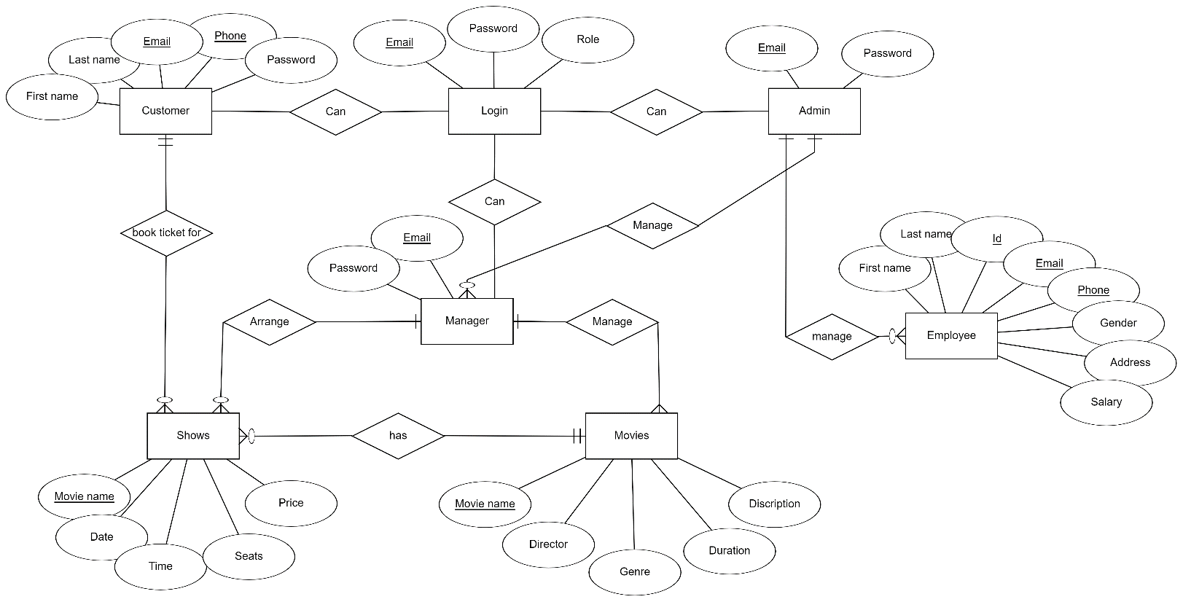

**Tools Used:**

To develop this project, we have used the following:

• Notepad++

• Atom

• Browser

• HTML

• CSS

• PHP

• JavaScript

• Bootstrap

**System Images against the Specification:**

Screenshots of most of the GUIs has been provided below:

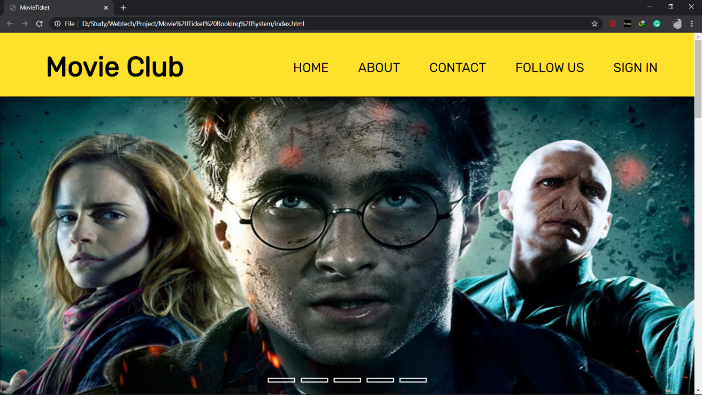

Screenshot: Home Page

It is the home page. Here are some useful menus for quality customer service. Here is also a slide show of trending.

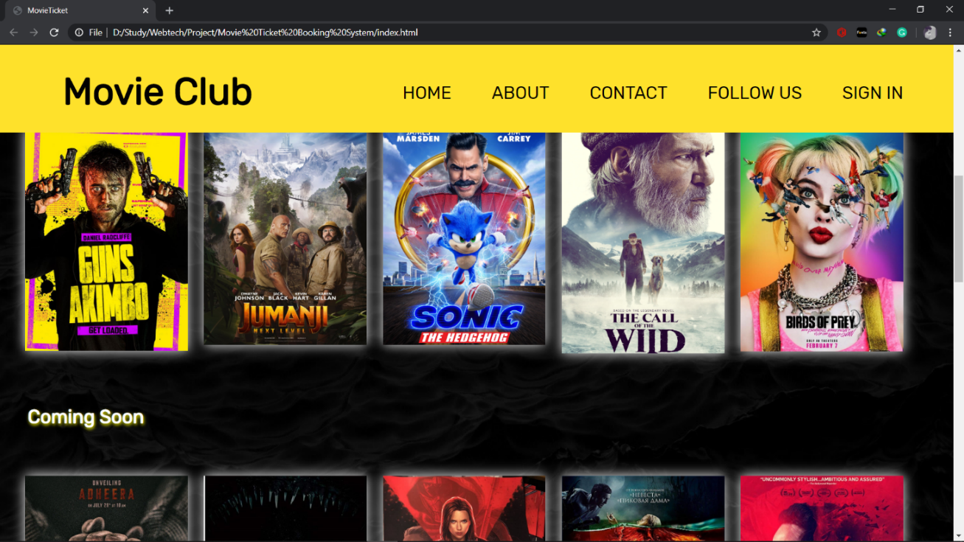

Screenshot: Home Page

Here are some movie posters which are being played now and will be coming soon.

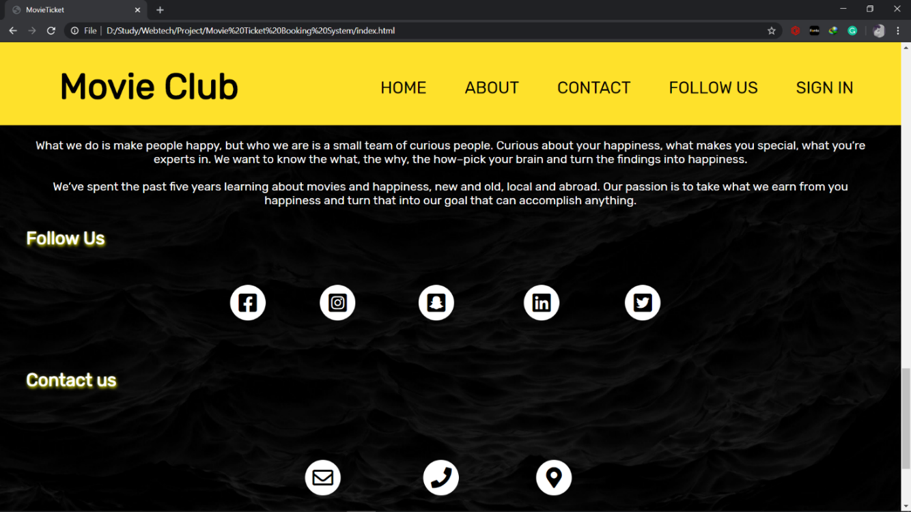

Screenshot: Home Page

Here are some useful details about the demanding site owning company.

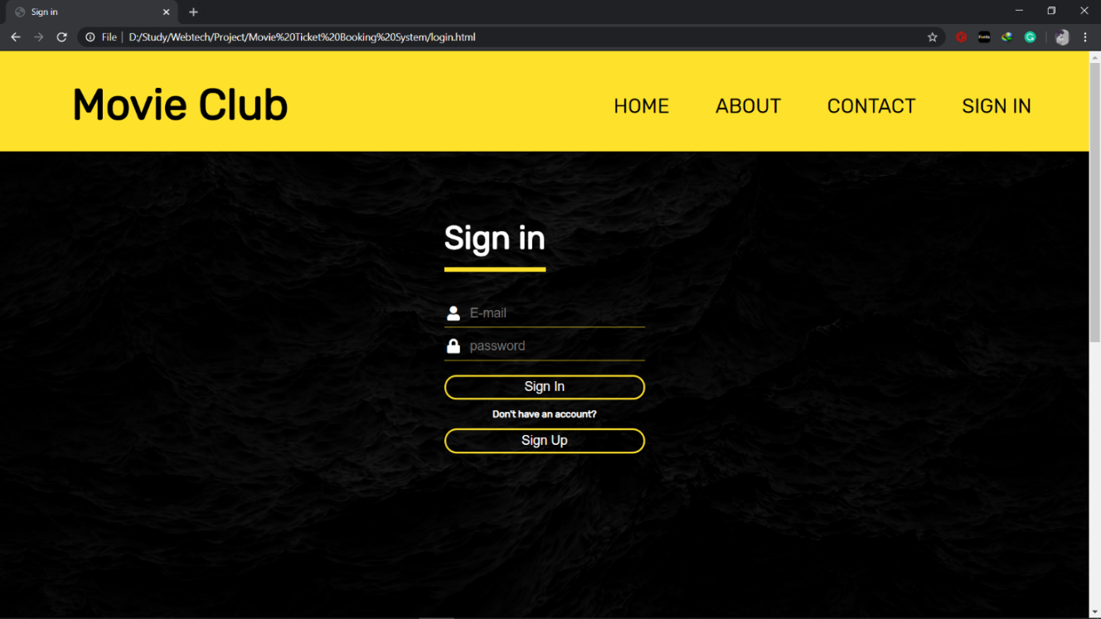

Screenshot: Sign in Page

This is the Sign in GUI. Customers, admin, manager can login through this page.

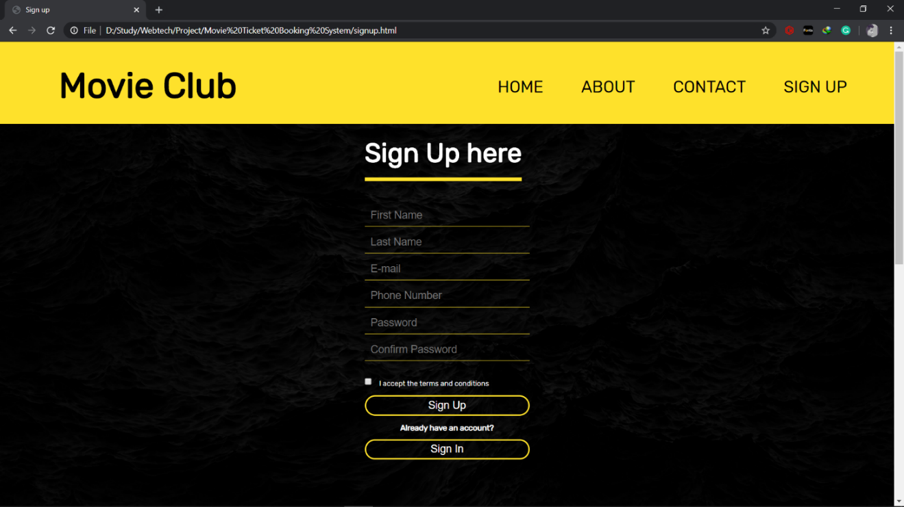

Screenshot: Sign Up Page

This is the Signup GUI. New customers can sign up so that they can book movies.

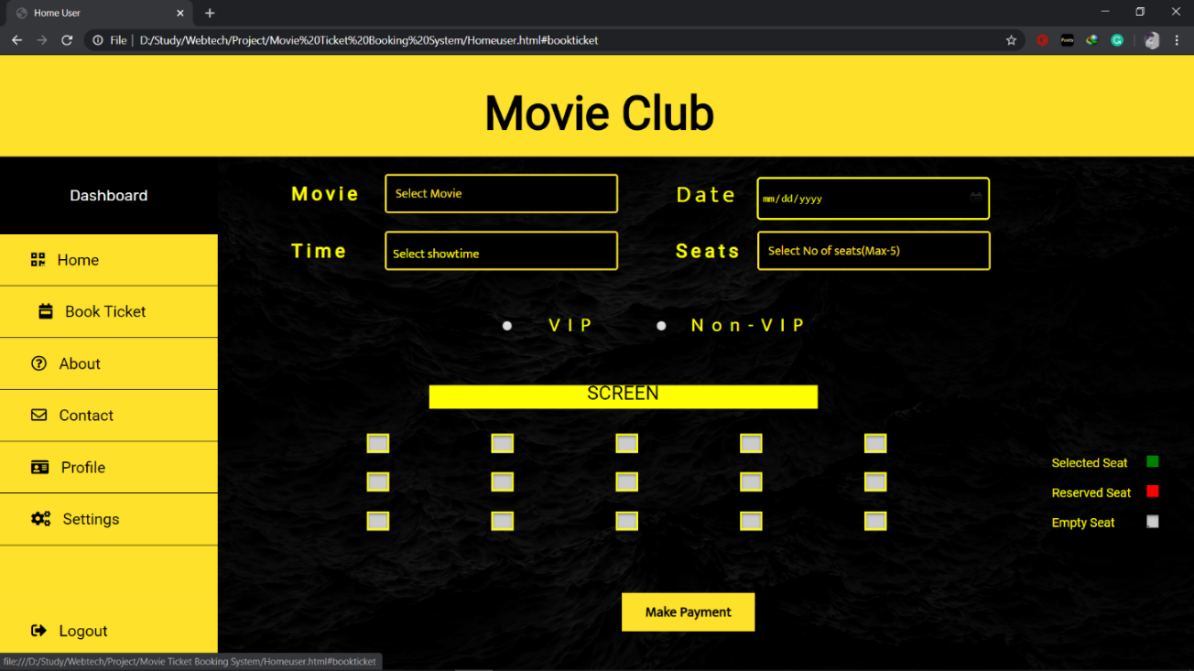

Screenshot: User ticket booking Page

This GUI is for booking tickets for customers. Besides this is the customers menu for their navigation.

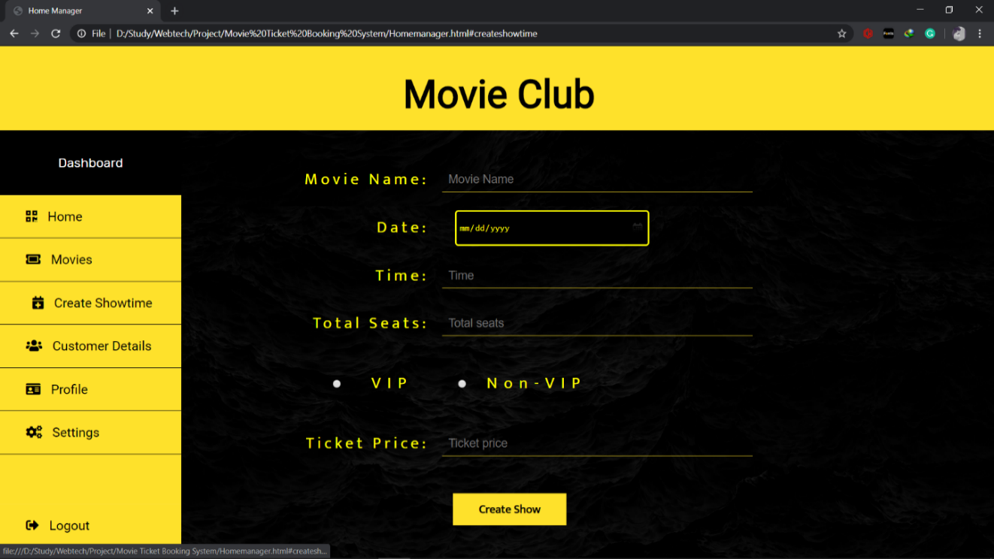

Screenshot: Creating Show Page

This GUI is for managers, so that they can create in show. Customers will book tickets regarding this show creation.

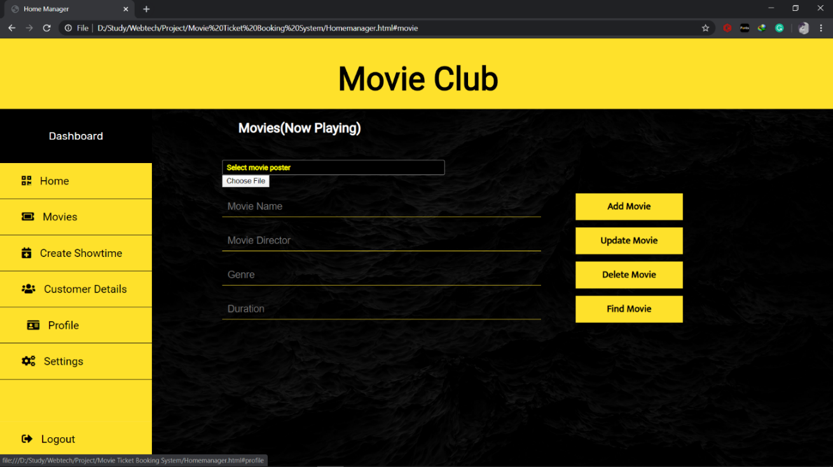

Screenshot: Movie managing Page

This GUI is for managers to manage the movies that will be the sites main feature of fraction and attraction.

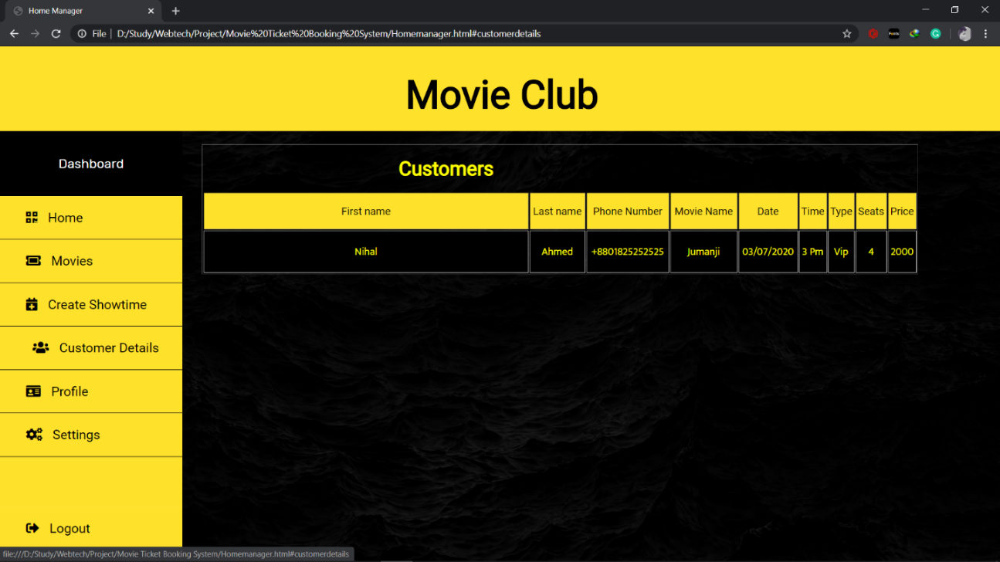

Screenshot: Customer details Page

This GUI will help to look up for customers regarding their bookings of tickets.

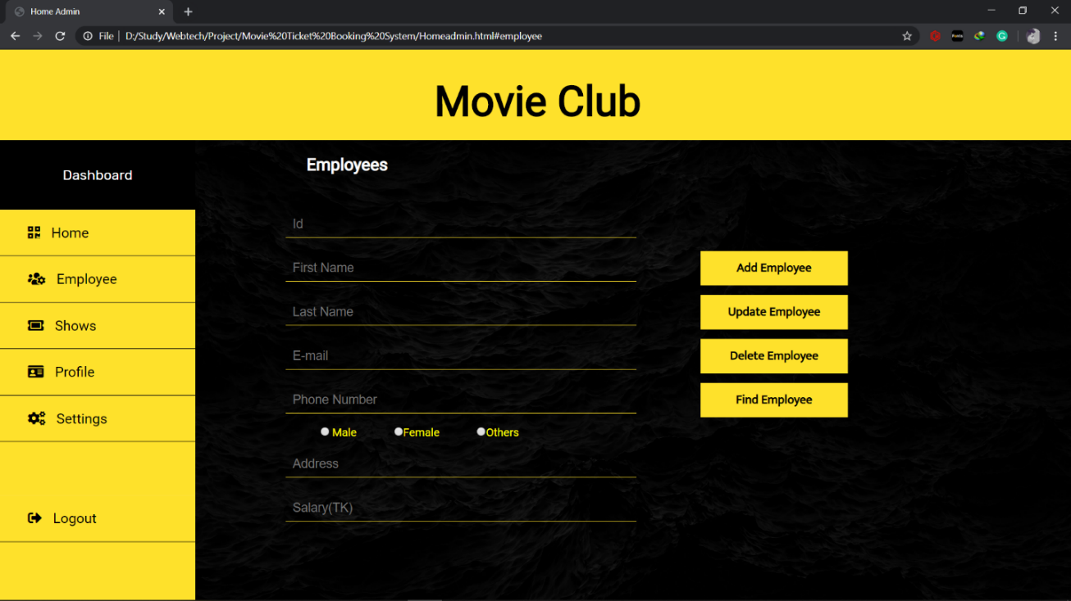

Screenshot: Managing employee Page

This GUI is for admin. By using this GUI admin can manage employees who will work for the theatre.

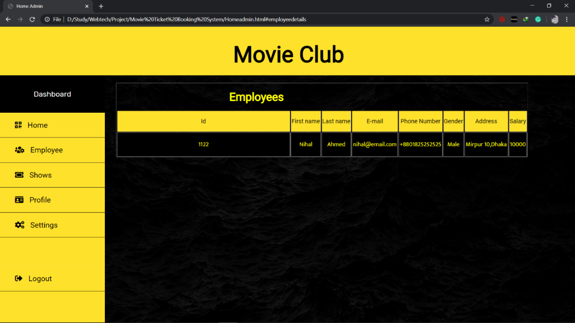

Screenshot: Employee details Page

This GUI will help to look up on employees who are working for the theatre.

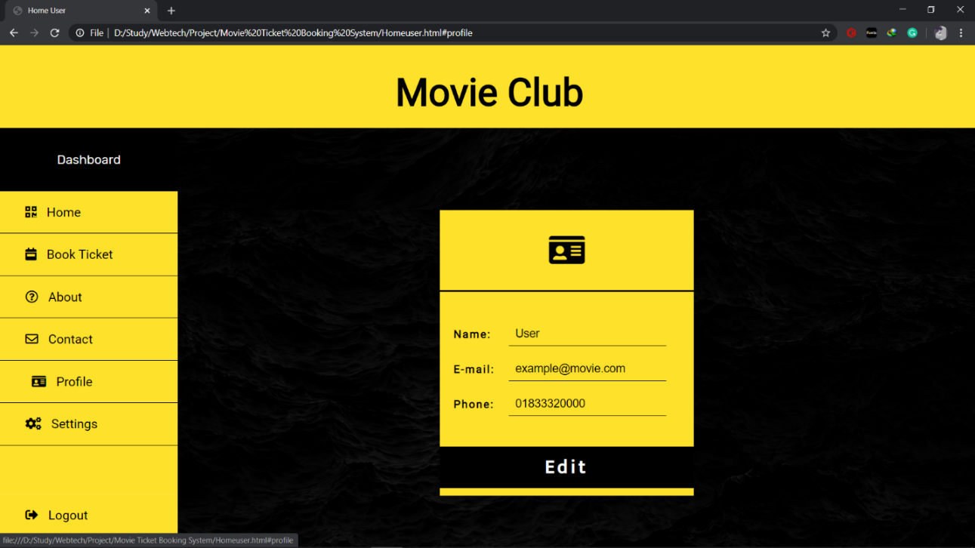

Screenshot: profile card

This GUI represents the profile card for the website users. Users can look upon their profile and edit it if needed.

**Impact of this Project:**

The aim of proposed system is to develop a system of improved facilities and features. The proposed system can overcome all the limitations of the existing system. The system provides proper security and reduces the manual work.

* Security of data.
* Ensure data accuracy.
* Proper control of the higher officials.
* Minimize time needed for the various processing.
* Greater efficiency.
* Better service.
* User Friendliness and interactive.
* Minimum time required.
* Much variety of features.

**Limitations and Possible Future Improvements:**

Although we have put our best efforts to make the software flexible, easy to operate but limitations cannot be ruled out even by us. Through the software presents a board range of options to its users some intricate options could not be covered into it; partly because of logistic and partly due to lack sophistication. Paucity of time was also constraint; thus, it was not possible to make the software foolproof and dynamic.

Considerable efforts have made the software easy to operate even for the people not related to the field of computers but it is acknowledged that a layman may find it a bit problematic at the first instance. The user is provided help at each step for his convenience in working with the software.

|  |  |  |  |  |  |
| --- | --- | --- | --- | --- | --- |
| **CO1 and CO3 Evaluation: Project Report Evaluation** | | | | | |
| **Project Proposal**  **(5)** | **Background**  **Study**  **(5)** | **Requirement Analysis**  **(5)** | **Entity**  **Diagram**  **(5)** | **System Images**  **against the**  **Specification (5)** | **Total (25)** |
|  |  |  |  |  |  |
|  | | | | | |